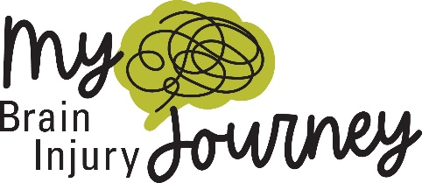

Sample Newsletter Article/Blog Post
Every year, at least 2.8 million Americans sustain a traumatic brain injury. While many people go on to make a full recovery, there are more than 5 million people in the U.S. living with a permanent brain injury-related disability – that’s one in 60 Americans.
Every brain injury is different. There’s an often-repeated adage among the brain injury community: “If you’ve seen one brain injury, you’ve seen one brain injury.” The circumstances leading to the injury, the care that the patient received, the brain injury survivor’s life before and after the injury, how the brain changes over time – these are all aspects that contribute to the unique, dynamic nature of brain injury, making the brain injury survivor’s journey an extremely personal one.
Those who are affected by brain injury – survivors, their loved ones, and the people who treat them – all have their own stories to tell about how brain injury has changed their lives and set them on a different path. The parts of their lives that have stayed the same, and the parts that have forever changed. Who they were before brain injury became a part of their lives, and who they are after.
Living with brain injury is a journey – and it’s not linear. This journey is not one of a straight line, with simple steps. Sometimes, it’s one step forward and two steps back. Maybe even three. Sometimes the path may be hidden, and sometimes the traveler requires assistance getting to the next stop along the way.
It takes a special kind of resilience to navigate a journey like life after brain injury – a journey with no clear end point. And sometimes, when it’s your journey, it’s you – and only you – on that path.
Even though everyone’s brain injury journey is different, our collective outcome as those affected by brain injury is a singular one: to navigate life as best we can, and to find joy, happiness, and peace in the unexpected. Making the best of the cards we’re dealt and finding those pockets of joy in this new version of life is not only the best gift brain injury survivors can give themselves, it’s how we gain the strength and empowerment to come together and speak our truth about our experiences, our lived realities, and our hopes for the future.
Everyone’s brain injury story deserves to be told, and it’s up to us, as survivors and supporters, to tell them. Because the more people who know the truth about brain injuries, the fewer misconceptions there will be. This Brain Injury Awareness Month, we encourage you to share your story about your own unique brain injury journey. More information on Brain Injury Awareness Month and how to share your brain injury journey can be found at biausa.org/MyBrainInjuryJourney.

